**Train Planning**

**Fixed Information starting Points**

TOC’s VWC and AXC Supply train diagram data to agreed numbers of service trains. Example provided for Both customer.

LTP is the Long-Term Plan and the diagrams each customer intends to run for that period

STP is the Short-Term Plan and the amendments to the LTP for the coming week considering engineering and demand requirements

Diagram Example

Diagram No

Start/End loc

Start/End Time and Head Code

Mileage

Periodicities of Exams defined by Engineering Dept through defined periodicities of tasks

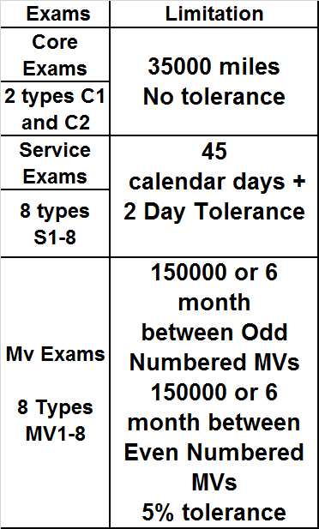

Service Locations we have 11 in total spread throughout the UK, 8 on Cross Country and 3 on WC with the addition of Central Rivers being the home depot where all Heavy Maintenance and Examinations take place.

WC XC

|  |  |  |  |
| --- | --- | --- | --- |
| Polmadie |  |  | Craigentinny |
| Holyhead |  |  | Tyne Yard |
| Crewe L&NWR |  |  | Crofton |
|  |  |  | Longsight |
|  |  |  | Barton Hill |
|  |  |  | Laira |
|  |  |  | Penzance |
|  |  |  | Eastleigh |
|  |  |  |  |

Fleet Sizes

20 trains on WC all 5 Cars

|  |  |
| --- | --- |
| **221101** | **West Coast** |
| **221102** | **West Coast** |
| **221103** | **West Coast** |
| **221104** | **West Coast** |
| **221105** | **West Coast** |
| **221106** | **West Coast** |
| **221107** | **West Coast** |
| **221108** | **West Coast** |
| **221109** | **West Coast** |
| **221110** | **West Coast** |
| **221111** | **West Coast** |
| **221112** | **West Coast** |
| **221113** | **West Coast** |
| **221114** | **West Coast** |
| **221115** | **West Coast** |
| **221116** | **West Coast** |
| **221117** | **West Coast** |
| **221118** | **West Coast** |
| **221142** | **West Coast** |
| **221143** | **West Coast** |

58 trains on XC a mix of 4 car and 5 car

4 Cars

|  |  |  |  |  |  |  |  |  |  |  |  |  |  |  |  |  |  |  |  |  |  |  |  |  |  |  |  |  |  |  |  |  |  |  |  |  |  |  |  |  |  |  |  |  |  |  |  |  |  |  |  |  |  |  |  |  |  |  |  |  |
| --- | --- | --- | --- | --- | --- | --- | --- | --- | --- | --- | --- | --- | --- | --- | --- | --- | --- | --- | --- | --- | --- | --- | --- | --- | --- | --- | --- | --- | --- | --- | --- | --- | --- | --- | --- | --- | --- | --- | --- | --- | --- | --- | --- | --- | --- | --- | --- | --- | --- | --- | --- | --- | --- | --- | --- | --- | --- | --- | --- | --- |
| |  |  |  |  | | --- | --- | --- | --- | | **220001** | **220011** | **220021** | **220031** | | **220002** | **220012** | **220022** | **220032** | | **220003** | **220013** | **220023** | **220033** | | **220004** | **220014** | **220024** | **220034** | | **220005** | **220015** | **220025** | **221136** | | **220006** | **220016** | **220026** | **221140** | | **220007** | **220017** | **220027** | **221141** | | **220008** | **220018** | **220028** | **221144** | | **220009** | **220019** | **220029** |  | | **220010** | **220020** | **220030** |  |   **5 Cars**   |  |  | | --- | --- | | **221119** | **221129** | | **221120** | **221130** | | **221121** | **221131** | | **221122** | **221132** | | **221123** | **221133** | | **221124** | **221134** | | **221125** | **221135** | | **221126** | **221137** | | **221127** | **221138** | | **221128** | **221139** | |

**Current State**

We take all the above information and through tools available in Microsoft Office and construct various documents to allow us to construct weekly/daily plans to make sure trains receive stated maintenance.

**Other considerations**

Ad-Hoc repairs

Failures

Interaction with industry software Genius/Integrale/Ravers/Gemini

Bombardier MMS:- MAXIMO

Fixed Manpower limitations